Dear Andrew.

This is ‘The Mysterious Dimitri Khalezov’ who would like to disturb you once more regarding a web page on http://tech.groups.yahoo.com/group/Cognoscence/message/4555 recently published by you (or by someone who pretends to be you).

I would like to thank you for being so polite towards my mysterious humble person and for your abstaining from outright insults (which are not uncommon in a society of the US Government-appointed shills and full-time Internet forum-trolls earmarked to fight all dangerous conspiracy theories on various forums). I found you article indeed unusually polite which betrays in you an intellectual person.

Nonetheless, despite of your article being written in a seemingly polite manner and despite of the fact that it does not contain any outright insults, it is still insulting due to some reasons which are described below.

The point is that there are three distinctly different groups of people who could claim things in regard to the 9/11 (as well as in regard to other similar high-profile events):

- eye-witnesses who are not experts (or who are not necessarily experts);
- experts who are not necessarily eye-witnesses;
- conspiracy theorists who are not necessarily experts and who are definitely not eye-witnesses.
Judging from the point of elementary logic (I guess you are a logical person, after all), you can argue against claims of the third group by implying that they are wrong in their presumptions (which could still be polite – depending on how you would construct and word your actual criticism). You could also argue against claims of the second group by challenging their technical/scientific conclusions and still you could do that without actually insulting them personally (because to argue in such a manner is the way of life in scientific circles and no scientist could feel offended for being criticized on account of his claims). I hope you understand what I mean.

However, when it comes to arguing against the first group, it is not so easy to argue with them without actually insulting them (as you try to do in your article). Unlikely you could challenge a testimony of an eye-witness without insulting such an eye-witness personally. Because, unlike an expert or a conspiracy theorist (or a scientific theorist) an eye-witness technically can not be ‘right’ or ‘wrong’ in his testimony. There are only 2 states of affairs when it comes to an eye-witness: he could only be a genuine witness who says the very truth, or a fake witness who intentionally lies to the court. In the first case he honestly performs his duty. In the second case he commits nothing less than a crime which is punishable by imprisonment. By challenging my testimony (not my technical explanation of the WTC pulverization or burned cars or undamaged bathtub wall I mean but my claims that I knew back in the 80s about the WTC emergency nuclear demolition scheme) you call me nothing less than a criminal. Let’s call a spade a spade. All your sweet words you used in the article and your seeming ‘politeness’ towards my mysterious person can not hide the main point behind your challenge: you claim that I am a false eye-witness, i.e. you blatantly accuse me of being a criminal.

Then it is very unfair to use such a ‘polite’ manner of describing alleged ‘merits’ of my video presentation and alleged ‘polite’ nature of my humble mysterious person as you did. Because a false witness is a criminal first of all and, in fact, it is quite a disgusting kind of a criminal. It does not matter in this light if he is personally ‘polite’ or not and it does not matter in this case if his presentation is plausible to any extent or not. It is just part of the crime and nothing less than that. So, I suggest you re-write your article and to change the priorities. You have to go to the main point: call me an impostor, not a ‘new conspiracy theorist’. Challenge not the point that I can’t satisfactorily explain why the bathtub wall was not collapsed (which I have no obligation to explain in any case). You have to challenged, instead, my claims that I used to serve as a commissioned officer in the Soviet nuclear intelligence and I learned still back in the 80s about existence of the WTC emergency demolition scheme.

You have to say plainly:
“This mysterious person claims that he allegedly knew in the 80s about the alleged WTC emergency nuclear demolition scheme while allegedly being a commission officer in the alleged Soviet nuclear intelligence. But I don’t believe this impostor. I state he is a liar.”

This will be an honest conduct from you.

You see, Andrew, I acted in this case in a minimum of 4 capacities in the same time:

1) I was indeed a former officer in the Soviet nuclear intelligence for 5 years. I knew back in the 80s about existence of the WTC nuclear demolition scheme. I could go to any court of law, lay my palm on the Holy Bible and testify that before the judge, adding, if necessary, that “may The Most High punish me right on the spot if I lie”.

2) I indeed personally knew chief 9/11 organizer. To the extent that I even drank wine with him in the early breakfast of September 12, 2001 while discussing some sensitive details of the 9/11. (Which is also well known fact to the American FBI, by the way, therefore they even attempted to obtained extraditions of both of us to America in 2003). I could also testify about this before any court of law revealing A LOT of details (for example details of stealing of nuclear-tipped missiles from “Kursk” submarine, etc.).

The abovementioned are two of my capacities as an eye-witness. You can’t challenge them by mildly calling me ‘wrong’ or ‘incompetent’ because it is not the way to deal with eye-witnesses. An eye-witness can not be ‘wrong’ or ‘incompetent’. He could only be an honest eye-witness, or a liar, a criminal. Moreover, to be honest with you, you can not even challenge me from merely technical point of view to the two abovementioned points because I have a lot of documentary proof to confirm either point. So, even if you want to call me liar, you still have no chance. If this case comes to the court I will prove what I claim.

Then, I attempted to add here two additional capacities as an expert/conspiracy theorist:

3) Because unlike many others I knew very well physical properties of underground nuclear explosions, I presumed that I could provide more than satisfactory explanation why the WTC buildings were ‘dustified’ before their collapses. Which I did. In this case I assumed an additional role of a technical expert (again ADDITIONAL role, not a primary role of a technical expert). You might not like my explanation, but I do not care, to be honest. Firstly, because I have no obligation to explain it neither to you, nor to others. It was just my gesture of good will. If you don’t like it – then don’t take it. It was optional in any case. Primary was not this explanation, but my statement that I knew about the WTC nuclear demolition scheme back in the 80s. So, if you don’t like my technical explanation on nuclear demolition effects – don’t hesitate to challenge it and to offer your own explanation on nuclear demolition effects. I am very easy person and I might agree with you if I find your explanation on nuclear demolition effects more plausible than my own.

4) Because I spent a lot of time studying various details of the 9/11 (not less than 5 years I think) I could also feel like I possess not only some expert knowledge of physical properties of underground nuclear explosions, but also some expert knowledge in the 9/11 details (such as some important facts in the 9/11 timeline, the media coverage, slips of tongues of various officials, various discrepancies in official documents, and various other irregularities). Therefore I assumed an additional role of a 9/11 conspiracy theorist (again ADDITIONAL role). Because sometimes ago I learned from the FBI that the real reason to demolish the WTC was (you know what, I will not repeat it), I also attempted to construct a harmonious whole theory which I called in scientific manner ‘9/11thology’ that attempted to explain the 9/11 in its entirety, not each aspect of the 9/11 in isolation from the rest of its important aspects. Which I guess was successful explanation.

In any case you can challenge me in a common way (as you would challenge any other conspiracy theorist) only those aspects of my presentation which are covered in the above clause 4) (i.e. my capacity as a ‘conspiracy theorist’).

To a certain extent (within frames of undeniable fact of the ‘WTC nuclear demolition’ only) you may try to challenge also my technical explanations in regard to the WTC ‘dustification’ – i.e. you can challenge me in my capacity of an ‘expert’ as covered in the above clause 3). Which means that you could offer your own explanations of the nuclear demolition technical details, instead, but without denying the actual fact that the WTC nuclear demolition has indeed taken place.

In both of these cases you could still exercise you trade-mark politeness and ‘objectivity’. Moreover, you are even welcome to challenge these, because you might offer some better points than mine and it will bring us all closer to the truth.

However, you have absolutely no chance to encroach upon my mysterious humble person in my capacity of an eye-witness - as covered by above clauses 1) and 2) without actually insulting me by implying that I am an impostor, a false-witness and therefore a criminal.

Hope you have gotten my point now and will re-write your abovementioned article accordingly.

Copy of this my letter to you will be sent to some of my followers and friends and also to some followers of Judy Wood – just to inform you in advance.

Sincerely yours,
Mysterious Dimitri Khalezov.

P.S.

I would like also to remind you that despite of all your seeming ‘objectivity’ you always try your best to avoid discussing one of the main points and ‘smoking guns’ of the WTC demolition – the pre-9/11 definition of the ‘ground zero’ term in old English dictionaries, along with the desperate attempt of the US Government to re-define this term and/or to ‘broaden’ its definition in all post-9/11 English dictionaries. I think it would be truly objective of yours, if you stop avoiding it and pay some serious attention to this particular point.

Some beginning of a ‘raw’ version of my book that also deals with the ‘ground zero’ term’s manipulations by the US authorities is enclosed below for you reference (it starts from the next page below).
Prologue. The largest “non-nuclear” blast ever...

"The car bomb is the nuclear weapon of guerrilla warfare."

-- Washington Post columnist Charles Krauthammer

It is not so, dear Mr. Krauthammer. It is vice-versa.

It happened a long time ago – that time no one has ever complained yet that those notorious “suit-case nukes” have been allegedly stolen from Soviet nuclear arsenals, no politician has come up with any public claim yet that “evil Iran” allegedly pursues its “clandestine nuclear weapons program” and even “evil North Korea” has not been accused of developing its alleged nuclear weapons yet. It happened in remote 1983.

This largely forgotten today perpetration was, indeed, the best of the early “car-bombings” that became nothing than a “golden standard” for the future nuclear terrorism. Ironically, despite the fact that it was not performed by any “conventional” Muslim terrorists, it indeed inspired many of them and continues to inspire them even up to this day. Even though the true Muslim terrorists could not obtain any “suite-case nuke” (and majority of those poor guys did not even suspect that such thing did exist in This World), they all, nevertheless, were greatly encouraged by that particular event. The event itself was cunningly timed by its actual perpetrators to the greatest political mistake of the then US leadership – which at that time, after the first US Beirut Embassy bombing, has decided to participate in the Lebanese Civil War and ordered the US Navy to bombard Lebanese guerillas storming positions of Lebanese Government forces.

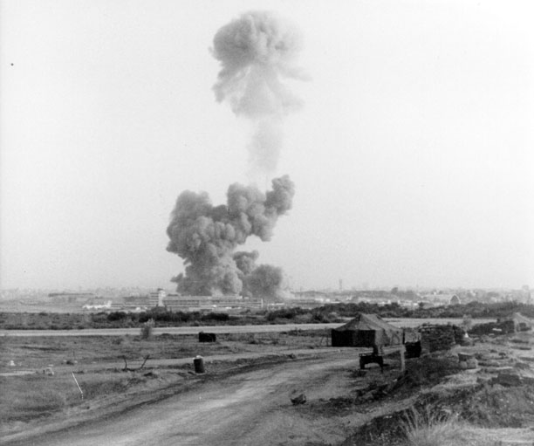

This is on official photograph (alias “file-photograph”) of 1983 Beirut barracks bombing – it is from an official site of US Department of Defense, thanks to its courtesy. This is indeed the file-photograph of that event. It shall be known: conventional explosions do not feature any mushroom cloud. If you see anything like this all you have to do is to believe your eyes because you are not mistaken: you see a very nuclear explosion…
Official information on this bombing, at least as provided by Wikipedia: the 1983 Beirut barracks bombing was a major incident on October 23, 1983, during the Lebanese Civil War. Two truck bombs struck separate buildings in Beirut housing US and French members of the Multinational [peacekeeping] Force in Lebanon, killing hundreds of servicemen, the majority being US Marines. The blasts led to the withdrawal of the international peacekeeping force from Lebanon, where they had been stationed since the Israeli 1982 invasion of Lebanon. [The so-called] "Islamic Jihad" [organization hitherto unheard of] [allegedly] took responsibility for the bombing, but that organization is thought to have been a nom de guerre for Hezbollah receiving help from the Islamic Republic of Iran. On around 6:20 AM, a yellow Mercedes-Benz truck drove to Beirut International Airport, where the 1st Battalion 8th Marines, under the US 2nd Marine Division of the United States Marine Corps, had set up its local headquarters. The truck had been substituted for a hijacked water delivery truck. The truck turned onto an access road leading to the Marines' compound and circled a parking lot. The driver then accelerated and crashed through a barbed wire fence around the parking lot, passed between two sentry posts, crashed through a gate and barreled into the lobby of the Marine headquarters. By the time the two sentries had locked, loaded, and shouldered their weapons, the truck was already inside the building's entry way. The suicide bomber detonated his explosives, which were [allegedly] equivalent to 12,000 pounds (about 5,400 kg) of TNT. The force of the explosion collapsed the four-story cinder-block building into rubble, crushing many inside. It is said by a US federal district court judge in his ruling to have been the largest non-nuclear blast ever (deliberately) detonated on the face of the earth. [Do not believe this claim, because it was a deliberate lie. When there were standard 10-ton aviation bombs available and, moreover, widely used – even during World War II, to claim that laughable 5.4 metric tons of TNT was “the largest” blast was nothing, but ridiculous. This blast was, of course, larger than any known non-nuclear blast, because this particular blast itself was the nuclear one.] According to Eric Hammel in his history of the Marine landing force, "The force of the explosion initially lifted the entire four-story structure, shearing the bases of the concrete support columns, each measuring fifteen feet in circumference and reinforced by numerous one and three quarter inch steel rods. The airborne building then fell in upon itself. A massive shock wave and ball of flaming gas was hurled in all directions." In the attack on the American barracks, the death toll was 241 American servicemen: 220 Marines, 18 Navy personnel and 3 Army soldiers. Sixty Americans were injured [and unlikely they had any chance to survive, because of received doses of radiation exceeding nominally “lethal” ones by several times]. This was the deadliest single-day death toll for the United States military since the 243 killed on 31st January 1968 — the first day of the Tet offensive in the Vietnam war [meaning that one suicide bomber with 5.4 metric tons of the TNT could instantly inflict casualties on the same rate as those inflicted during a full day of heavy fighting by the entire regular North Vietnamese army at its strategic full-scale offensive…]. About 2 minutes later, a similar attack occurred against the barracks of the French La 3ème Compagnie, 1er Régiment de Chasseurs Parachutistes (3rd Company of the 1st Parachute Infantry Regiment), 6 km away in the Ramlet al Baida area of West Beirut. Another suicide bomber drove his truck down a ramp into the 'Drakkar' building's underground parking garage and detonated his bomb, leveling the eight-story building. In the attack on the French barracks, 58 paratroopers were killed and 15 injured, in the single worst military loss for the French since the end of the Algerian war. In addition, the elderly Lebanese custodian of the Marines' building was killed in the first blast. The wife and four children of a Lebanese janitor at the French building also were killed. Many of the French soldiers had gathered on their balconies moments earlier to see what was happening at the airport (where their American colleagues have been just nuked). They apparently saw a strange picture similar to that captured by the above photograph… Probably, if one would make a competition for the best picture of mushroom cloud of an atomic explosion, the above photo would undoubtedly win the first prize – it is the ideal one: an atomic mushroom cloud should look exactly like the one – vapor and dust separately... This particular photo, of course, was not made by those poor French paratroopers, because unlikely their photo-cameras could survive the second nuclear blast; it was taken by someone else. But, probably, from their balconies the French soldiers could see something like that before the second “truck” with alleged “TNT load” has “arrived” to their own barracks. It is suspected, however, that there were no any trucks at all. The two “mini-nukes” were simply planted inside the both premises by “someone” whose visit was not suspicious to either French or American servicemen. So, it shall be suspected as being truly “inside job”. The man, who installed both “mini-nukes” in both premises, must have been well-known to both – French and Americans – and must have been above any suspicion…

Culprits: despite an apparent “success” of the attack (I guess that it is clear to everybody that to instantly send to Hell several hundreds of infidels is an apparent success – at least judging from a point of view of any Muslim warrior), nobody claimed responsibility for it. This was the strangest feature of this particular act of alleged “terror”: no “terrorists” were in a hurry to come up to claim their laurels… It became even stranger when one hitherto unheard of organization bearing exceptionally idiotic name “Islamic Jihad” has eventually stepped forward to claim responsibility for this bombing in an anonymous telephone call.

It is probably known that “Jihad” itself is a typically Koranic term – meaning “Holy War against unbelievers who suppress Muslims”. So, logically, “Jihad” is “Islamic” by default, and no Muslim would ever name any organization “Islamic Jihad”, since the “Jihad” itself can’t by anything, but “Islamic”. Such a name could have only been invented by some non-Muslims, moreover, by those non-Muslims, who were in a real hurry. If they only had time to use their brains a little bit longer, they would choose some other name. Just to illustrate how strange it sounds to real Muslims, try to imagine, that, let’s say after some despicable act of terror in North Korea the next day all North Korean newspapers would publish information that an organization named “Imperialistic Capitalism” claimed responsibility for that act of terror. Now, please, try to imagine that combination of these two words: “Islamic Jihad” indeed sounds about as idiotic as in the above example. Moreover, the circumstances in general surrounding this nuclear bombing and eventual appearance of hitherto unheard of “Islamic Jihad” with its claims looked exactly as idiotic as in the above example too. Up to this day it is not known anything at all about that mysterious “Islamic Jihad”. Neither address of its headquarters, nor names of its leaders, nor any if its political agenda has ever been known. All what is known about this strange organization is that from time to time someone telephoned to mass media and claimed that this “Islamic Jihad” was responsible for such and such nuclear bombing. This so-called “Islamic Jihad”, in fact, became so much associated with nuclear bombings that for some security officials words “nuclear” and “Islamic Jihad” began to sound like synonyms. It was not surprising than that even on the 9/11 the very first responsibility was claimed by the very same organization, at least so it was reported by many TV channels about noon time September 11, 2001…

Later it was claimed that “Islamic Jihad” was allegedly nothing else, than a nom de guerre for Hezbollah – which itself was a Shi’a Revolutionary organization, inspired by teachings of Ayatollah Khomeini – at least so the Wikipedia article claims – citing various official sources.

It shall be known, however, that Hezbollah in Lebanon was officially inaugurated 2 years later after the Beirut barracks bombing occurred. Hezbollah came into existence only in 1985. So, despite that the US investigators several years later attempted to claim that Hezbollah had organized the 23 of October, 1983, bombing while still being “underground”, nobody took their bizarre claims seriously. Hezbollah has never existed “underground” and it is a well-known fact. Once it has been created it immediately proclaimed itself publicly. Anyhow, in response to the belated claims of the US investigators, Hezbollah, as well as Iran and Syria (neither of whom could have any nuclear, not even to say about mini-nuclear weapons back to the 80s), have firmly denied any involvement in that despicable double nuclear bombing of American and French peacekeepers.

Possible motives: “someone”, who initially instigated the civil war in Lebanon, needed that war to go on, implementing a well-known principle: “divide and rule”. Those American and French peacekeepers were apparently unwanted. That is why they were “politely” hinted that they were not really welcome. So, the peacekeepers had to leave. They left and the civil war in Lebanon continued.

However, this was not all. The United States Government was caught by that development virtually with their pants down and so it was placed into an extremely awkward position. For some reasons it did not dare to admit it publicly that the American peacekeepers were unwelcome in Lebanon to the extent that it has been decided to show them the door by annihilating some of them using an atomic bomb...

Actually, it was the biggest strategic mistake of the US Government. Would the US administration admit it honestly then, in 1983, that both – the First US Embassy Bombing, and the Marines Barracks Bombing – were indeed nuclear events, the US officials would not need to lie continuously about all “truck-“ and “car-bombings” for the next 25 years to come. Moreover, there would be a pretty good chance that due to a broad public interest in regard to possible origins of “mini-nukes” in hands of so-called “terrorists”, these “terrorists” would not dare to use their “mini-nukes” again, and neither 1995 Oklahoma-, nor 1993 WTC-, nor 1996 Khobar Towers-, nor 1998 US Embassies-, nor any other nuclear bombings would ever occur. If subjected to a public scrutiny from the very beginning, these bombings would never be blamed on “Iran”, “Iraq”, “Hezbollah”, or “Al-Qaeda”. The discerning public would quickly figure it out who was really capable of manufacturing such precise mini-nuclear devices and would quickly draw right conclusions. Perhaps, even the 9/11 could have been avoided in such a case… As one of the Beirut Barracks Bombing’s eye-witness – the then “embedded” with the Marines NBC News Correspondent Jim Maceda would put it 25 years later: “…a ground zero that would, inexorably, lead to the Ground Zero, a generation later…” He was 100% right, this perspicacious Mr. Maseda: it was indeed the very Beirut’s ground zero that lead to the Manhattan’s Ground Zero. And it happened due that apparently wrong decision of the Reagan’s Administration – which elected not to explain to gullible public what the term “ground zero” really meant in the then English language...

Still, the US Government which decided to lie rather than to say the awful truth had to respond somehow to an intense public outcry that followed the bombing. So the then Reagan Administration ventured on an adequately unprecedented measure in response to the unprecedented Beirut bombing. Only a day later the US army launched a totally unexplainable and unprepared surprise Grenada Invasion, which attracted understandable international criticism and eventually cost the United States much more damages than the very “non-nuclear” blast in Beirut it was intended to distract attention from. If the US marines in Lebanon by 23 of October 1983 were still considered as being true peacekeepers by almost every nation (including Arabs and other Muslims), the US marines that landed on Grenada shore on 25 of October 1983 were condemned as true aggressors by almost everyone, including Americans themselves. Still, it was only a chance for the US Government to distract undue public attention from the true nature of the mysterious Beirut blast aka “the largest non-nuclear blast ever (deliberately) detonated on the face of the earth”… And apparently that timely “small victorious war” against small Grenada worked out. Exactly as another “small victorious war” did later in similar circumstances in a popular 1997 Hollywood movie “Wag the dog”…

It is good to remember this story, because it will be helpful in understanding a true position of the US Government in its unprecedented 9/11 cover-up and in its infamous “war” against the so-called “terror” that followed those apocalyptic events…

John Walcott, FBI agents, and haz-mat suits.

"If liberty means anything at all, it means the right
to tell people what they do not want to hear."
- George Orwell, Preface to Animal Farm (1946)

To begin with, I would make it so bold as to quote here some statement concerning one of September 11 heroes – Detective John Walcott, a “Ground Zero” responder, who has spent a considerable amount of time in the WTC site while cleaning the rubble of the World Trade Center. He spent there enough time to develop a strange disease: acute myelogenous leukemia in its terminal form. Only two paragraphs of this statement from a scary article “Death by Dust” managed to contain and to reveal to us practically all those “unexplainable” strange things – which the reader will need as basic premises to understand the main point of this book:

“…Because Walcott was a detective, he ended up spending his five-month stint not just at Ground Zero, but also at Fresh Kills. As much as he choked on the Lower Manhattan air, he dreaded the Staten Island landfill. Walcott knew everything in the towers had fallen - desks, lights, computers. But apart from the occasional steel beam, the detritus that he sifted through there consisted of tiny grains of dust - no furniture pieces, no light fixtures, not even a computer mouse.

At times, the detectives would take shelter in wooden sheds, in an attempt to get away from what Walcott likes to call "all that freaking bad air." One day, he was sitting in the shed with his colleagues, eating candy bars and drinking sodas, when some FBI agents entered. They were dressed in full haz-mat suits, complete with head masks, which they had sealed shut with duct tape to ward off the fumes. As Walcott took in the scene, contrasting the well-protected FBI agents with the New York cops wearing respirator masks, one thought entered his mind: What is wrong with this picture?...”

Yes, Mr. Walcott, unfortunately something was wrong, very badly wrong with that picture…

Those FBI agents, who were not ashamed to wear those full haz-mat suits, moreover, sealed shut with duct tape, in front of unprotected “commoners”, knew the “third” and the ultimate truth I am going to talk about in this book. That is why they do not suffer now from leukemia or from any other kinds of terminal cancer. Those FBI agents will apparently live long and fulfilling lives, despite briefly visiting the “Ground Zero”…

If you would only open a contemporary dictionary to look at the true meaning of this strange term, you would not need to ask that question; you would understand immediately what was wrong with the “Ground Zero”:

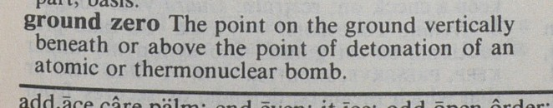

All possible meanings of “ground zero” term as defined by The New International Webster’s Comprehensive Dictionary of the English Language (Deluxe Encyclopedic Edition 1999, ISBN 1-888777796), page 559.

It should be mentioned here also that Mr. John Walcott eventually managed to survive, unlike many of his colleagues who used to work at the “Ground Zero” and who were less lucky... On December 17, 2007, it was briefly mentioned in some Internet news that Mr. John Walcott at last underwent some truly strange (and extremely painful) operation – bone marrow transplantation. So from now on, he could continue to live (on special immuno-depressant drugs that would prevent his transplant rejection; and without leaving his house due to the fact that his immune system no longer exists and any kind of infection could easily be fatal).

For someone who does not know what “marrow transplantation” means, I am obliged to explain. Marrow transplantation is required for patients who suffered heavy doses of either penetrating or residual ionizing radiation (or both) and whose own bone marrow (that is responsible for blood regeneration) is completely killed by these heavy doses of radiation.

It is a strange property of radiation – it always strikes bone marrow cells most heavily compare to any other cells of human body. That is why majority of victims of radiation suffer from leukemia – the heavier radiation dose was – the more of their bone marrows is killed, so the heavier is their leukemia.

Mr. John Walcott, apparently, suffered from the heaviest possible condition – all the time before he obtained his bone marrow transplant, he lived exclusively on donors’ blood, because his own blood was not regenerating at all.

In addition to killing or severely damaging bone marrow, ionizing radiation, especially when someone inhales or ingests some radioactive dust or radioactive vapor, could cause various kinds of cancer that could affect virtually any part of human’s body, or even a few parts simultaneously. However, it is pretty easy for dishonest doctors and health officials to give some plausble “explanations” in regard to these cancers. They can claim that it is due to “asbestos”, “toxic fumes”, “toxic dust particles” etc. But when it comes to bone marrow damage, these cheaters are helpless. The bone marrow damage could only be caused by ionizing radiation.

So, when you hear that someone needs marrow transplantation, all you have to do is to believe your ears: it is a case of radiation poisoning.

And that is exactly why those FBI agents wore full “haz-mat” suits with head masks even sealed shut with duct tape “to ward off the fumes” while visiting the “Ground Zero”. They wanted to suffer from neither leukemia, nor from any cancer. And when they additionally sealed shut their head masks with duct tape, they did it not “to ward off the fumes” as believed by Mr. John Walcott. They did it in order to ward off some radioactive dust and especially radioactive vapor, which they wanted neither to inhale, nor to ingest.

About “ground zero”, “Ground Zero”, and this book’s author. Introduction to Orwellian “newspeak”: pre-9/11 and post-9/11 meanings of the “ground zero” term.

To begin with, I think it would be reasonable to remind some people (who have probably forgotten what the term “ground zero” used to mean before September 11, 2001) about the true meaning of these two words “ground” and “zero” strangely used together. There are few more definitions from various sources. Here are entire, unabridged definitions – “as is” – exactly as provided by respective dictionaries:

“ground zero” n. a point on the surface of land or water at or directly above or below the center of a nuclear explosion.
Collins English Dictionary, Major New Edition (Third Edition 1991, ISBN 0 00 433286-5 Standard).

“ground zero” n. a point on the ground directly below the center of a nuclear explosion.
Collins English Dictionary & Thesaurus, 21 Century Edition (second edition 2000, ISBN 0 00 472502-6).

“ground zero”. The place on the earth’s surface directly at, below, or above the explosion of a nuclear bomb.
The American Heritage Desk Dictionary (Edition 1981, ISBN 0-395-31256-6).

“ground’ ze’ro” – the point on the surface of the earth or water directly below, directly above, or at which an atomic or hydrogen bomb explodes.
Webster’s Encyclopedic Unabridged Dictionary of the English Language (Edition 1989, printed in 1994, ISBN 0-517-11888-2).

“ground zero” – the point on the ground vertically beneath or above the point of detonation of an atomic or thermonuclear bomb.
The New International Webster’s Comprehensive Dictionary of the English Language (Deluxe Encyclopedic Edition 1999, ISBN 1-888777796).

“ground zero” n: the point above, below, or at which a nuclear explosion occurs.
The Merriam-Webster and Garfield Dictionary (Paper back edition 1999, ISBN 0-87779-626-2).

“ground zero” n. the point on the surface of the earth at or directly below or above the centre of a nuclear explosion.
Penguin Student Dictionary (first published as The New Penguin Compact English Dictionary 2001, reprinted in this edition without supplementary material… ISBN 0-141-02818-1).

“ground zero” = point on the ground directly under the explosion of a nuclear weapon.
Dictionary of Military Terms (Peter Collins Publishing 1999, ISBN 1-901659-24-0).

“ground’ ze’ro” – the point on the surface of the earth or water directly below, directly above, or at which an atomic or hydrogen bomb explodes.
The Random House College Dictionary (Edition 1966, printed in 1973, Library of Congress Catalog Card Number: 68-19699).

“ground ze-ro” /,.’../ n [U] the place where a NUCLEAR bomb explodes, where the most severe damage happens
Longman Advanced American Dictionary (new, first published 2000, ISBN 0 582 31732 0).

“ground zero” noun 1 [C usually singular] the exact place where a nuclear bomb explodes: The blast was felt as far as 30 miles from ground zero. 2 [U] the site of the former World Trade Center in New York City, which was destroyed in an attack on September 11, 2001.
Cambridge Advanced Learner’s Dictionary, 2nd Edition. (This is a post 9/11 edition, widely available).

Are you surprised? If you don’t believe your eyes and prefer to run to the nearest book store to buy some dictionary, don’t be in a hurry. When you arrive to such shop you will be surprised even more, because it is no longer possible to find any dictionary with pure old definition of this strange term. Those dictionaries printed before 9/11, such as mentioned above, that contained the only true meaning of “ground zero” term have been long time ago removed from book-shelves and replaced with some newer ones. Unfortunately, the very English language was one of the first victims of the 9/11 perpetration… So, instead of rushing to a book store, try to ask some of your friends if they have any – in case of good luck you might succeed in finding some old big English dictionary that was not victimized by the linguistic part of the 9/11 cover-up.

Etymology of this term is easily traceable. In a military specific part of English language there was a term “zeroing in” with meant exact aiming of a weapon onto some target. With advent of aviation bombs and especially missiles this term changed a little bit – in regard to missiles, bombs and other projectiles. The exact spot on the earth surface that is aimed by such a projectile began to be called “ground zero”. It had nothing to do with either “explosion”, or “devastation”, but exclusively with “aiming of a projectile”. When first nuclear weapons came into existence they were first made in a form of aviation bombs and missiles. So, logically, term “ground zero” expanded to embrace the exact hypocenter of an atomic (and later also hydrogen) explosion – since it was exactly “ground zero” as an aim of a projectile carrying its atomic load, so that “ground zero” in an old sense of “aim” and “ground zero” in a new sense: “hypocenter of a nuclear explosion” – always coincided. Once again this term has expanded, because nuclear bombs would more likely explode above the ground, rather than on its surface. So the “ground zero” began to mean not just the exact spot on the earth hit by a projectile before a nuclear explosion followed, but rather projection on to the earth surface of a hypocenter of such a nuclear explosion – be it above the ground, or even below the ground. Later it was also expanded in the same sense to embrace underwater nuclear explosions. As you can expect, soon the “ground zero” has completely lost its initial meaning (a target of a projectile) and people ceased to use that term in that particular sense. The second meaning (spot on the ground of-, or a projection to the ground of an exact hypocenter of a nuclear or a thermo-nuclear explosion) was to be its only meaning for the next 56 years since an atomic bomb was invented. Its initial meaning was totally out of use – practically no dictionary (with the rarest exception) did include the former meaning when defining the “ground zero” term. However, majority of big dictionaries in the second part of the XX century used to define this term by only its second meaning alone, which became the only meaning of these strange term: “a hypocenter of a nuclear (or a thermonuclear) explosion or its projection to the earth surface”. Strangely enough, the “ground zero” term used to be traditionally associated with the so-called “Manhattan Project” of 1942. It was so all the way down starting from 1945 and till about noon time of September 11, 2001. Ironically, since 9/11, this term began to be associated with another “Manhattan Project” – that of 1966, which has proven to be so disastrous only 35 years later…

So, do not be surprised that almost all new English dictionaries, printed after the 9/11, began to describe the term “Ground Zero” as allegedly having more than one sense. Some of them even “remembered” its very first and completely forgotten meaning (“aim of a projectile”), which was completely out of use for 50 years. In addition, at least 3-5 new meanings have been ascribed to this term, ranging from alleged “great devastation”, “great disorder” and “busy activities” to some alleged “basic level” and “starting point”. Some preferred another approach: editors of a new Longman Dictionary of Contemporary English, for example, defined “ground zero” as a “place where bomb explodes” without mentioning anything at all that such a “bomb” supposes to be only a nuclear or a thermo-nuclear one. In addition to all of it, now almost all dictionaries – either big or small – began to include this (to be exact “these”) definitions. The term “ground zero”, obviously because of being too specific, prior to the September 11 affair existed only in really big English dictionaries – such as Webster’s Unabridged, full Collins, full American Heritage, and similar (and there it has only a single meaning). It did not exist in smaller dictionaries – such as those intended for students and for advanced learners (the only exception was the Longman Advanced American Dictionary – mentioned above). For example, the “ground zero” term was absent in Oxford Advanced Learner’s Dictionaries of 4th, 5th and 6th Editions, published before September 11, 2001. Even Oxford’s 4th special “Encyclopedic” version (that was about 50% larger compare to a normal one) did not include any “ground zero’s” definition. Only Oxford’s Advanced Learner’s Dictionary of 7th Edition first published in 2005 began describing this term at last. Post-9/11 editions of Macmillan English Dictionary for Advanced Learners and Longman Dictionary of Contemporary English, all kinds of new Merriam-Webster’s Dictionaries, majority of new American Heritage Dictionaries, new Collins English, Microsoft Encarta Dictionary, and many other new dictionaries and encyclopedias after the September 11 affair all began to include the “ground zero” term and to define it in a sense that it might allegedly have more than one meaning, trying all their best to divert attention of their readers from the former nuclear (and only nuclear) nature of that strange term. By the way, editors of the last mentioned above Cambridge Advanced Learner’s Dictionary have to be praised for not cheating their readers: they were brave enough not to include any misleading definition of “ground zero” into their post-9/11 dictionary, in sharp contrast to all other dictionaries editors at service of 9/11 cheaters. It was reported that there were even attempts to prove that “ground zero” was allegedly used to describe that location long before the September 11, 2001. All these post-9/11 linguistic efforts in regard to the “ground zero” are understandable, indeed. That strangely revealing name, rashly awarded by ABC specialists to the demolition grounds of the former New York World Trade Center, was obviously too revealing to leave that term in future editions of dictionaries with only its former sense alone…
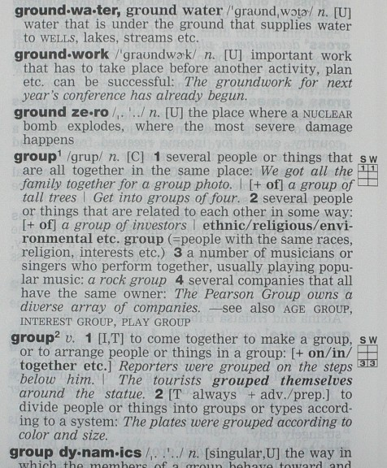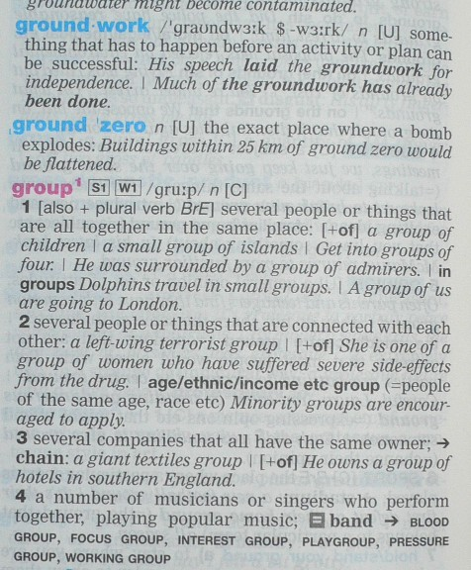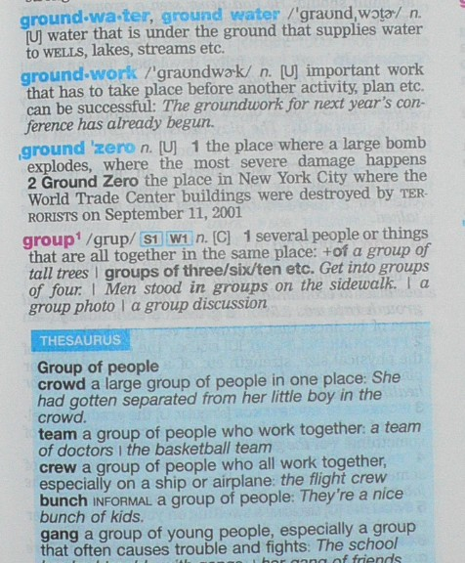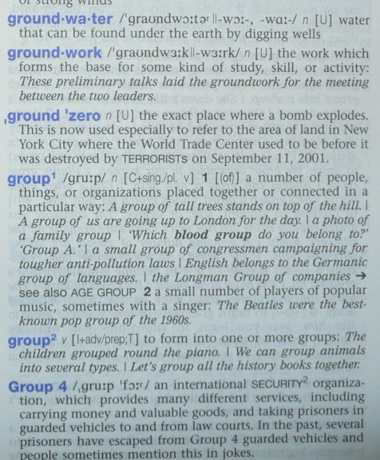

Example of mutation of meanings of the “ground zero” term from 2000 through 2007 in various Longman’s dictionaries. Top left – Longman Advanced American Dictionary (first published 2000, ISBN 0 582 31732 0). Top right – Longman Dictionary of Contemporary English (edition 2003, ISBN 0 582 77649 X). Example of this term’s usage in the top right one is particularly impressive: have you ever heard that a certain explosion of a “bomb” could flatten buildings within 25 km (15.5 miles) radius? It is hardly possible, unless a “bomb” were something like 45 megaton (45.000 kiloton) in caliber or even mightier. Yet, the word “nuclear” is not there anymore… But in the original definition it was even in CAPITAL letters… Bottom left – Longman Advanced American Dictionary (second edition 2007, ISBN 978 1 40582 9540). Bottom right – Longman Dictionary of English Language and Culture (3rd edition 2005, 2nd impression 2006; ISBN 0 582 85312 5). Please note, that before it was the word “NUCLEAR” that was printed in capital letters in the “ground zero” definition. Now it is another word, printed in capital letters: “TERRORISTs”. Note also, that those dictionaries on the left – one above another – are the First and the Second editions of the very same dictionary: “Longman Advanced American Dictionary”, printed in 2000 and 2007 respectively. Here you can see a pure cheating of its reader: either before or after the “ground zero” definition other words’ definitions (“ground work”, “ground water”, “group¹”) including even samples of their usage are all exactly the same. But not that of the “ground zero”.

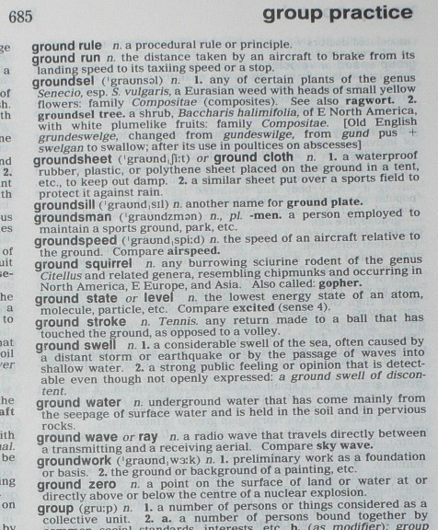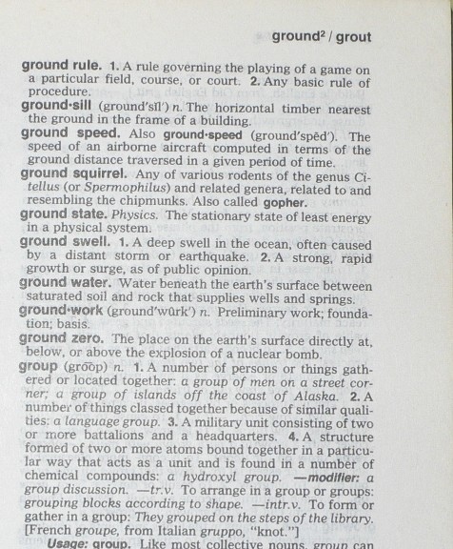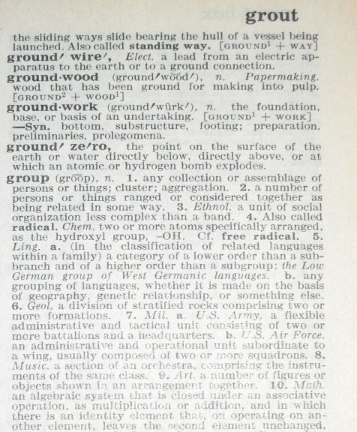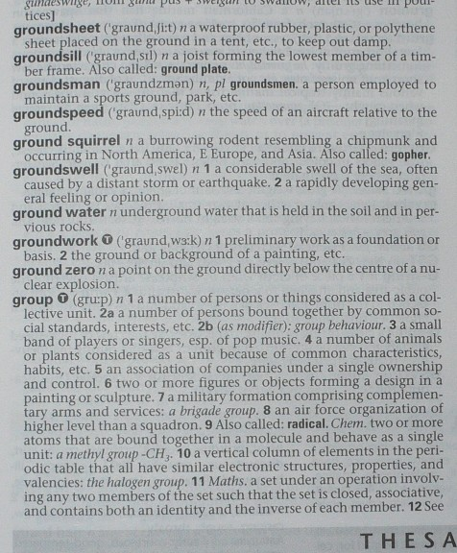

Starting from top left – clockwise - pages of: Collins English Dictionary 1991 (ISBN 0 00 433286-5 Standard), The American Heritage Desk Dictionary 1981 (ISBN 0-395-31256-6), Webster’s Encyclopedic Unabridged Dictionary of the English Language (Edition 1989, printed in 1994 - ISBN 0-517-11888-2), and Collins English Dictionary and Thesaurus - 21 Century Edition (second edition 2000, ISBN 0 00 472502-6) - describing every possible meaning of the “ground zero” term prior to the September 11, 2001...

Here are a few more examples of mutation of the “ground zero” definitions. These changes in definitions are especially interesting in the below examples, because here we have chance to compare editions of the similar dictionaries published before- and after 9/11. And these shameless changes are especially notable, because they seemingly have nothing to do with the 9/11 attack on the World Trade Center and with its sacred grounds now spelled with Capital Letters. Additional meanings are NOT about the WTC.

Example 1. Post 9/11-changes of the “ground zero” definitions in Random House College Dictionaries.

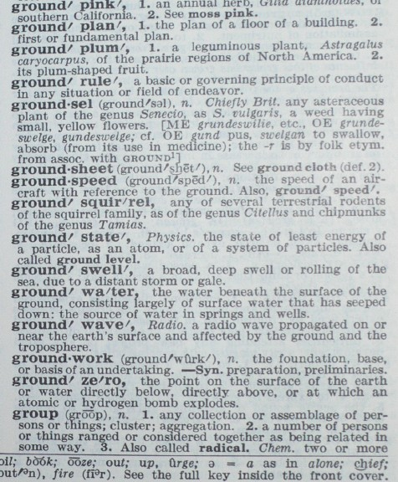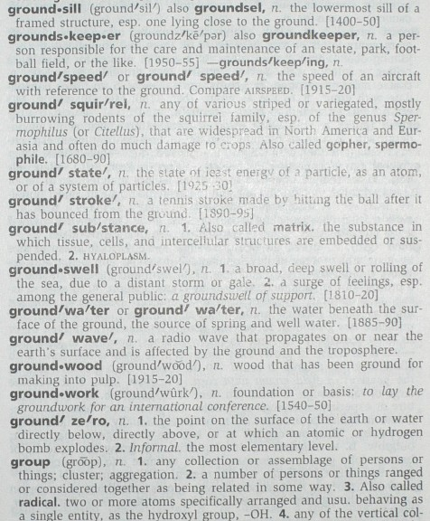

Left – The Random House College Dictionary (published 1973, no ISBN available, but only Library of Congress Catalogue Card Number: 68-19699). Right – The Random House Webster’s College Dictionary (first edition 1991, but this is an updated edition 2005, ISBN 0-375-42600-0). It is also interesting to compare this post-9/11 “broadened” definition of the “ground zero” with that in the biggest of all these dictionaries – the Webster’s Encyclopedic Unabridged Dictionary of the English Language – available in the previous picture.

Example 2. Post 9/11-changes of the “ground zero” definitions in The Merriam-Webster Dictionaries.

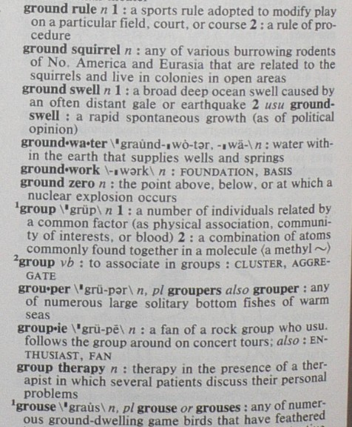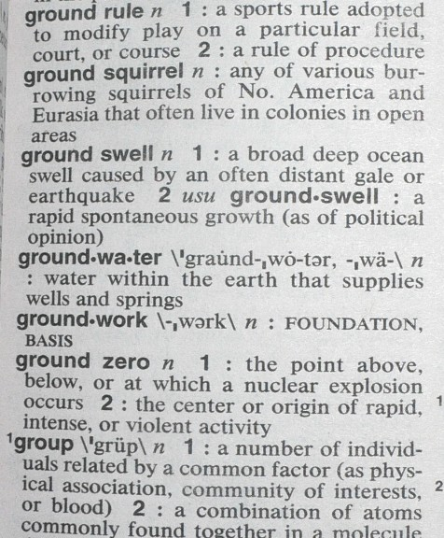

“Broadening” of meanings of the “ground zero” in two Merriam-Webster Dictionaries. Left – The Merriam-Webster and Garfield Dictionary (published 1999, ISBN 0-87779-626-2). Right – The Merriam-Webster Dictionary (New edition 2004, ISBN 978-0-87779-930-6). Please, note that other definitions are identical - such as that of “ground swell”, “ground water”, “ground work” and “group 1” – but not the definition of “ground zero”. Note also that an additional “meaning” here differs from that in the above Random House’s attempt.
Example 3. Post 9/11-changes of the “ground zero” definitions in Collins English Dictionaries.

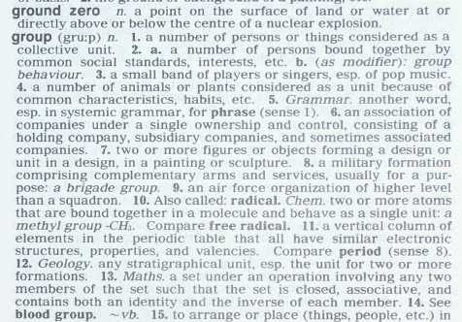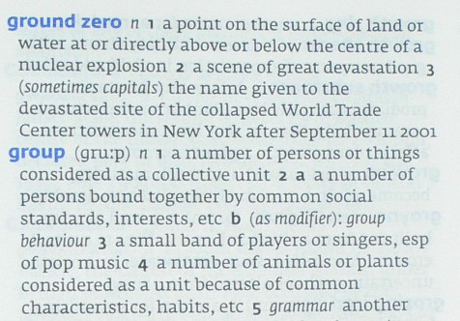

“Expanding” of meanings of the “ground zero” term in 2 Collins English Dictionaries. Left – Collins English Dictionary – published in 1991 Major New Edition (ISBN 0 00 433286-5 Standard). Right – new Collins English Dictionary (Ninth Edition 2007, ISBN 978-0-00-722899-7). Make sure to note that all definitions of the word “group” below our targeted term are absolutely identical. But the “ground zero”, in addition to the justifiable third meaning, has “strangely” acquired the second meaning in the after-9/11 edition of the same dictionary.

It would be understandable, if some extra definitions were added in regard to the demolition grounds of the WTC – like it was in the Cambridge Advanced Learner’s Dictionary, 2nd Edition – mentioned at the beginning of this Chapter, or like it was done in some Longman’s dictionaries – shown on the first set of pictures in this Chapter. But, strangely enough, it was not the case in the two examples above with the Random House’s and the Merriam-Webster’s concoctions. It was other extra definitions (which moreover, conspicuously differ from each other) added to the original “ground zero” meaning. And it seems that neither of these two conspicuously different additional meanings has anything to do with the Manhattan’s Ground Zero. Though, as you could guess, in reality there was a direct relevance between such a strange “broadening” in the former “ground zero” definition, and a nuclear catastrophe that occurred on the 9/11 in Manhattan that earned such a strange name to that place. Those so-called “good guys” from the FBI who did all their best to conduct the unprecedented 9/11 cover-up, simply could not afford to leave this most revealing definition with its former sense without “enlarging” it at least a little bit.

And we have to understand them, indeed… If they would not do such a “broadening” of the “ground zero” definition, it would not be only the FBI agents alone who would demand full haz-mat suits to be issued to protect their precious selves – like those FBI agents mentioned by poor John Walcott in the previous Chapter. Apparently, every ground zero responder and every Manhattan resident would demand his full has-mat suit too. Along with comprehensible explanation on what really happened on the Ground Zero.

To be honest, many friends of mine used to continuously ask me to write this book for the last few years, but I was always hesitating. It would never be possible for me to write this kind of book without properly being identified as its author. Even if I try to hide my identity, it wouldn’t be successful anyways – serious people would discover immediately who did it, so I really had no chance to stay anonymous. And I did not like to be famous even to a lesser extent – all my life I preferred to be a small guy, unknown to anyone and I was always happy with that state of affairs. This was actually only a reason behind my unwillingness to write anything like that – but this my unwillingness to write a book on this topic does not mean that I did not want to share with others something important that I knew about terrorism. Yes, I did not want to write any book, but I did honestly inform several different secret services of a few countries (including also those of the United States, of course) about the things I knew. Moreover, I did that a very long time ago. So I felt that my conscience was clear even if I would not proceed to any further step.

But once I had accidentally encountered the abovementioned story of poor John Walcott somewhere on the Internet, I have finally set up my mind and at last decided to write this book. It was not my friends, but those cowardly FBI agents wearing full haz-mat suits, who managed to finally convince me to reveal the truth about “Ground Zero” to others.

I am well aware that many so-called “American patriots” will hate me for this book (not even to mention those very FBI agents, and those scribblers at their pay who are parasitic on “terrorism”-related topics). And I am already anticipating how all of them will lash out at this book. But, honestly, I do not really care about their stupid opinions, especially considering that these guys and gals who parasitize on the concept of the so-called “terrorism” do not have opinions of their own anyway.

So the main reason for me to write this book is that I do not believe that those FBI agents wearing haz-mat suits should alone enjoy their exclusive knowledge about 9/11. It would be simply too unfair for the rest of descendants of Adam – who do not expect to be reduced to resemble those poor creatures described by George Orwell in his immortal “Animal Farm”.

I guess this book will allow other people to get to know also everything that happened on September 11, 2001: why there were no pieces of furniture or of a computer found among the “unexplainable” fine dust, why the WTC buildings collapsed with almost freefall speed, why the former WTC site was promptly dubbed “Ground Zero”, why all former “Ground Zero” workers now suffer from leukemia and other kinds of cancer, and why all those FBI agents, who had the exclusive knowledge, wore those full haz-mat suits while denying these very haz-mat suits to others…

Let the author of this book introduce himself first:

My name is Dimitri A. Khalezov (according to my current document “Kolesov”). I am 43 years old by now. I was formerly a commissioned officer in the Soviet military unit 46179, otherwise known as the "Special Control Service of the 12th Chief Directorate of the Defense Ministry of the USSR"; the 12th Chief Directorate itself was an organization responsible in the Soviet Union for safe-keeping, production control, technical maintenance etc. of the entire nuclear arsenal of the state. The same organization was also responsible for maintaining both Soviet nuclear testing grounds in Novaya Zemlia archipelago and near Semipalatinsk (now Kazakhstan) and for conducting all nuclear tests (practically only underground ones), as well as for the ecological safety of such nuclear tests. That is why I possess some specific knowledge which you will encounter below. After the dissolution of the Soviet Union I quit the military. Later, due to some specific knowledge possessed from my former military service, I was involuntarily involved in certain terrorist activities (luckily to myself more as a victim, than as an organizer of such activities). Because of my involuntarily involvement, I somehow managed to get to know not only certain exact details of September 11 attacks – both against the Pentagon and against the World Trade Center – but even the exact names of some of its main perpetrators, which are not known today – at least officially.

Someone might (and apparently will) think: “Why should we listen to your ravings, boy? Don’t you know how many idiots who claim to possess “specific knowledge” have appeared since September 11, 2001, to this day? You are probably 1001st – who claims to “know everything”… Why should we read your stupid book and take your idiotic claims seriously? Do you think we are not tired yet of reading all these crazy stories about September 11, lol?”

Well, I will answer this reasonable question: I am not that small boy, actually – even the US Government has already acknowledged my being a “big guy”: I was the first person who was officially arrested in 2003 on accusation of supplying travel documents to a certain, well-known Mr. “Hambali” – an alleged affiliate of a certain Mr. Osama bin Laden and an acknowledged leader of a so-called “Jemaah Islamiah” terrorist organization – who was blamed by President G.W. Bush, besides of all, for arranging that well-known meeting of would be hijackers of September 11 in Kuala-Lumpur, Malaysia in 2000, and for planning one more similar attack by hijacked planes against some skyscrapers in Los-Angeles. My humble self, in turn, was officially accused by the US Government for arranging fake travel documents for “Hambali” himself and for some other major operation planners of “Al-Qaeda” and “Jemaah Islamiah” terrorist organizations – including allegedly helping September 11 hijackers and the 2002 Bali bombers. Though unofficially my humble self was accused by the US Government in something much more serious than that… So while Mr. “Hambali” was arrested August 11, 2003, I was arrested right after him – August 13, 2003. Actually, I was just one step away from my extradition to the United States after my arrest in Bangkok, Thailand. Ironically, my extradition had not taken place not because I was too small and did now know anything – it was exactly vice-versa: the extradition had not taken place precisely because I indeed knew too much. Someone thought it wouldn’t be good for the US Justice to get such a guy revealing the full truth about September 11 in a court room. That is why I was excluded. All of this is just to confirm that my claims are not as stupid as may appear at first glance – I really know many things about September 11. At the next page there is a confidential document, copied from my case-file in the Thai Criminal Court – this chart composed by the FBI purports to represent an actual conspiracy of the infamous 2002 Bali Bombing – particularly links of senior operational planners of “Jemaah Islamiah” and “Al-Qaeda” to those who could supply them with appropriate travel documents. In this chart you can see Mr. “Hambali” – at the top left corner; the author of this book – on the down row, second from left. But most importantly – you can see the true organizer of September 11 perpetration on the same row, right. Unfortunately, his photo is not so clear in this secret chart, but it does not matter – I have a clearer one, which you will encounter later in this book. As you can see from this chart I am not such a little guy, actually. The American FBI put me in the very same row with the chief perpetrator of September 11 – just next to him. So, considering my status, awarded to me by the very US Government, I have an obvious privilege to be listened to.

I would dare to claim that I will name in this book at least one hitherto unknown chief perpetrator of September 11 attacks, including even showing his photographs and a photocopy of his passport. I will name here, in addition, at least two of his subordinates – also including photographs and photocopies of their passports. Moreover, I would dare to claim that I will explain in this book everything that has really happened with the World Trade Center and with the Pentagon – in precise detail, and I will also explain not only what has happened, but also why it has happened. However, to anticipate any possible mistrust, I would like to state in advance that neither the demolition of the World Trade Center, nor the attack on the Pentagon had anything to do with either the US Government, or with Osama bin Laden. Their chief organizer was another man, whom, thanks to Satan, I happened to know personally.

Below is a photo of a Uruguayan diplomatic passport, presented to me. It was a gift from a man, who was the main 9/11 perpetrator and a former deputy director of the Mossad. This passport was purported to be a sign of “appreciation” by his organization for a certain “consultation services” provided by me prior to the September 11 attacks. The date of issuance of this diplomatic passport was September 17, 2001.

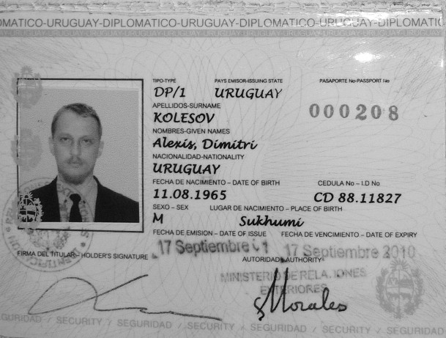
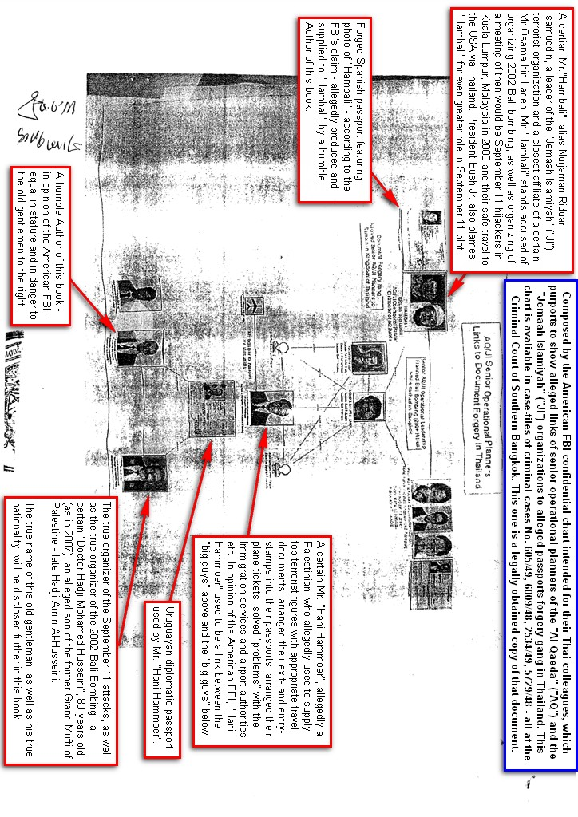
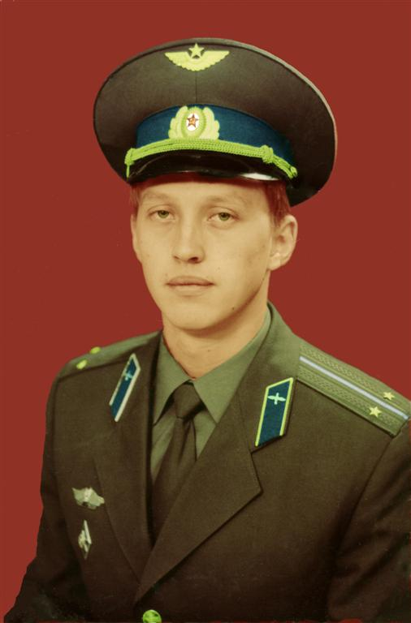

Author of this book in December 1987 – in a rank of First Lieutenant in his new military aviation uniform.

I wasn’t a pilot, but a military communication engineer; such an aviation uniform was issued to me when I was transferred from head-quarters of the 12th Chief Directorate of the Defense Ministry of the USSR to its Special Control Service and had to change my old uniform to the aviation uniform - worn by all officers of the then Soviet nuclear intelligence. It retained the tradition of wearing such an aviation uniform from the very beginning of this Service. At first it was operating some airplane-based flying laboratories which were used to collect various data after first atmospheric nuclear explosions – either domestic ones, or those of various adversaries of the USSR. Later some other methods were added to the Nuclear Control – such as seismic, ionospheric, radio intercepts analyzing, etc, which no longer required the officers to be always airborne, but the old traditional aviation uniform has remained in that Service. By contrast, the most of remaining officers of the 12th Chief Directorate wore gunnery uniforms – being considered as specialists in arsenal-keeping affairs, even though their actual “arsenal” was a nuclear one.

Full article by Jim Maceda is available here: http://worldblog.msnbc.msn.com/archive/2008/10/23/1584456.aspx
The entire story from which I am quoting is here: http://www.villagevoice.com/news/0648,lombardi,75156,2.html
Full story about Mr. John Walcott who underwent bone marrow transplantation was published here: http://www.nypost.com/seven/12172007/news/regionalnews/9_11_hero_meets_his_cell_mate_11157.htm and yet another shocking story was published here: http://abcnews.go.com/US/Story?id=2408066&page=1
Special Control Service (in Russian “SSK”) was a relatively independent service in different times subordinated to the GRU, to the Directorate of the Chemical Forces’ Commander and to the 12th Chief Directorate and often shifted between these three big Directorates; most of the time, however, SSK has been subordinated to the last one, being simply a part of the 12th Chief Directorate – which was known in the then Soviet Army as “12e GUMO”.

