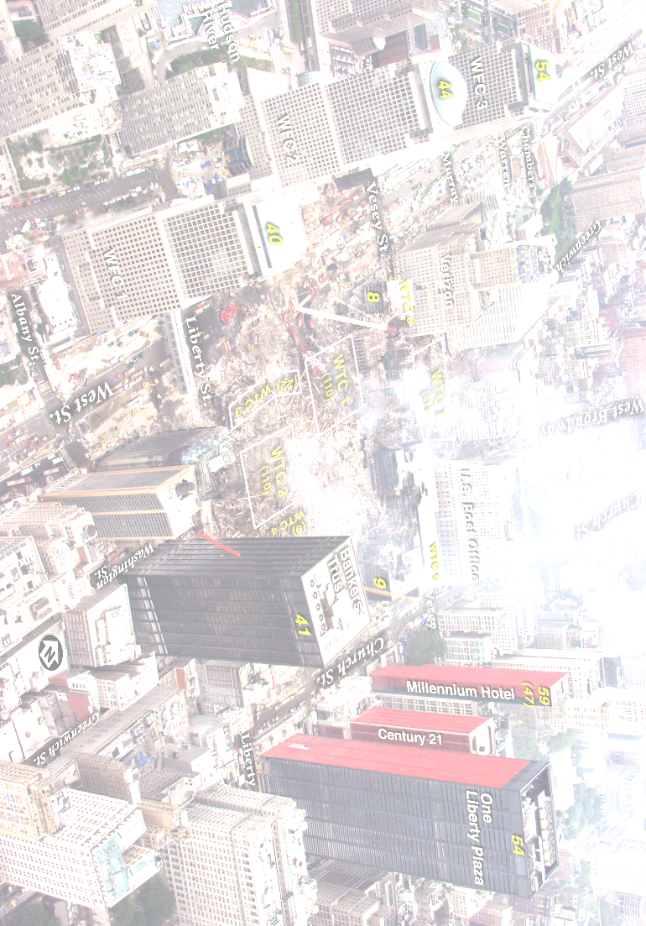
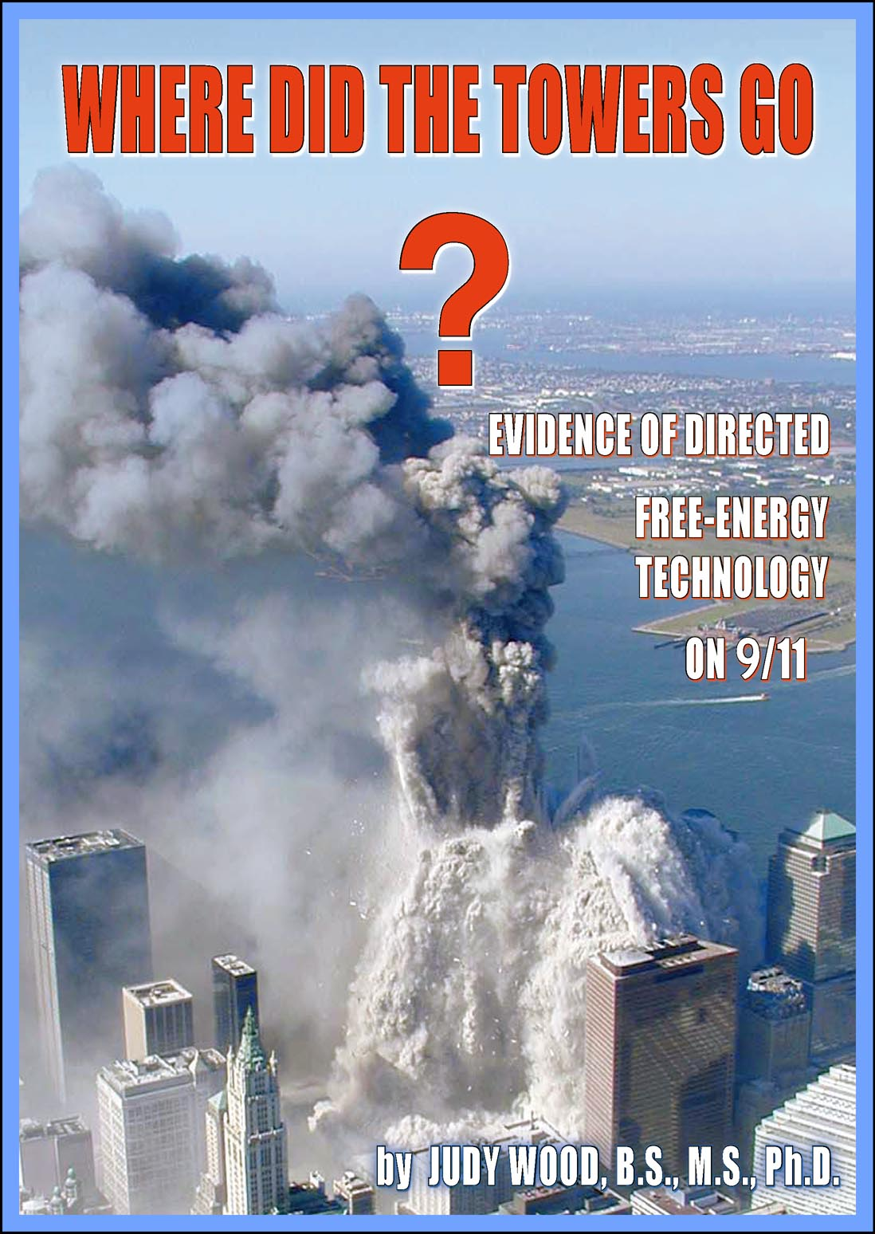  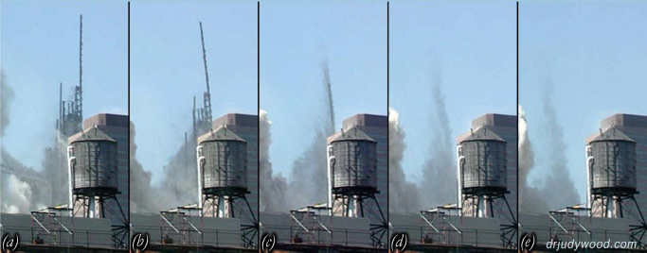 | On 11 Sept 2001, astounding events unfolded in the USA – including the complete destruction of World Trade Centre Towers 1, 2 and 7. These events changed the world – changed all our lives. Yet, it was years later that an official investigation was launched. All mainstream media sources generally take a view that those official investigations were adequate - and no one should have cause to seriously question them. However, the pictures on the left show that WTC 1 (like WTC 2) did not “burn up”, nor did it “slam down” – it was turned into dust in mid air – leaving almost nothing of the building itself.  Dr Judy Wood, a former Professor at Clemson University, USA, with degrees in Civil Engineering, Applied Physics and Materials Engineering Science, will present rarely seen graphic evidence which proves what really happened to those enormous structures. Her detailed scientific study exposes a challenging conclusion which most people have never had a chance to see, hear and evaluate. Dr Wood is the only person to submit elements of her forensic study in a US Federal court case in 2007, news of which was censored.  If you want to know more, please bring as many people as you can to this unique event – and study the evidence.  www.wheredidthetowersgo.com  www.drjudywood.com

Dr Judy Wood

Where Did The Towers Go?

Saturday 17 November 2012 - Doors Open 7.00 pm

Note
Put venue details here
Map: map link
Parking Note, Wheelchair Accessible?
Admission price of -- - Seating limited to approx ---
For further information contact: email , Tel: 0-----

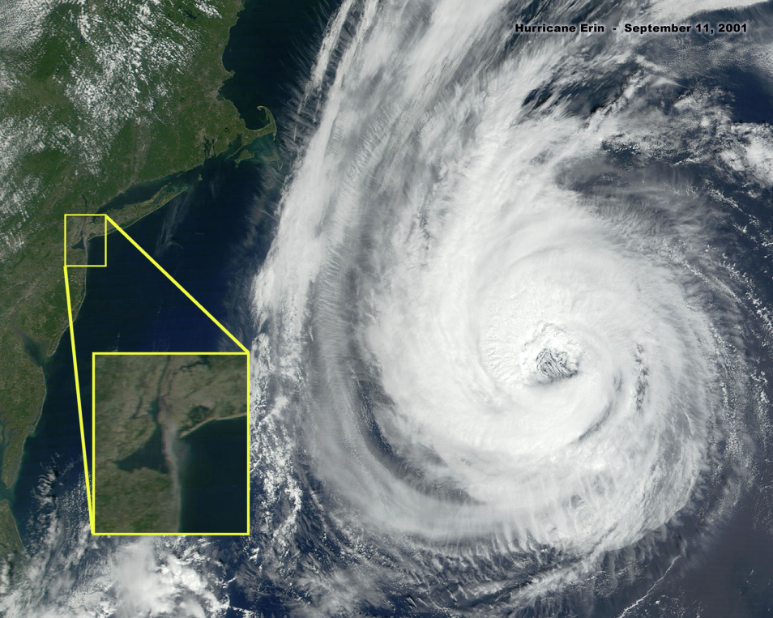
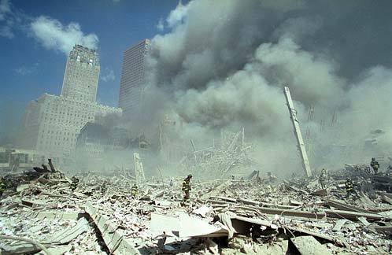
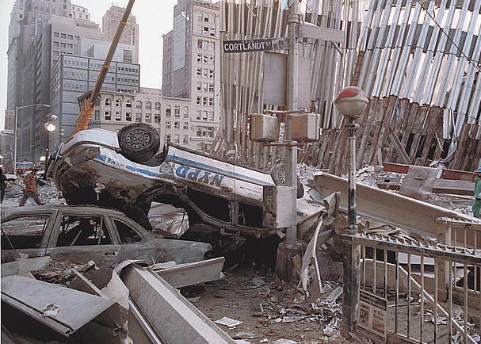
www.wheredidthetowersgo.com - www.drjudywood.com - www.checktheevidence.com - www.richplanet.net - www.nomoregames.net
www.wheredidthetowersgo.com - www.drjudywood.com - www.checktheevidence.com - www.richplanet.net - www.nomoregames.net
Why were some cars UPSIDE DOWN?
Why was Hurricane Erin closest to NYC at 8am on 9/11? Why was it barely reported?
By about 1pm on 9/11, where had the towers gone? Where is the debris? (This photo was taken at ground level.)
Here’s a small selection of the 911 Evidence that needs to be explained…
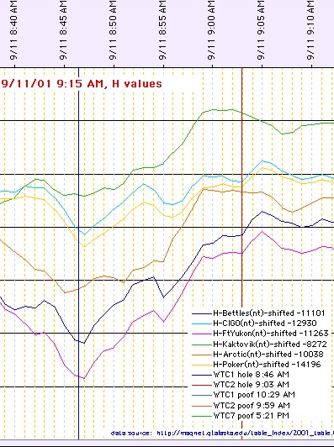
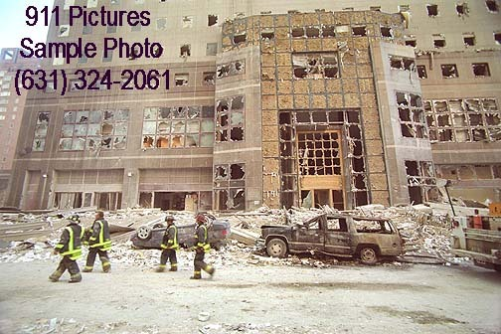
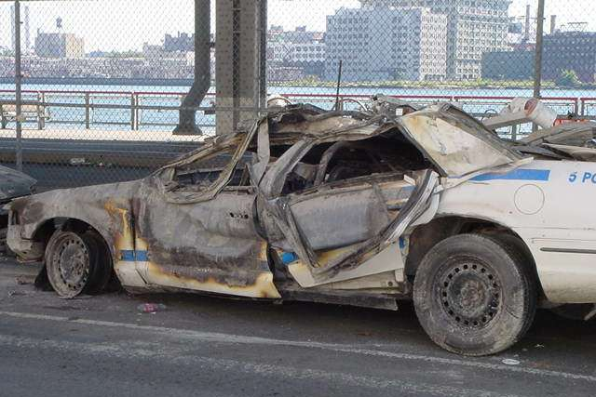
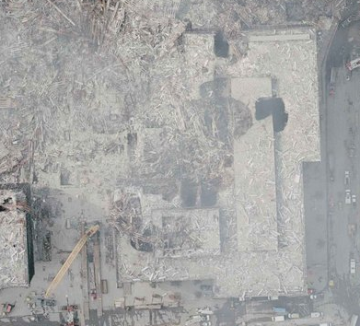
www.wheredidthetowersgo.com - www.drjudywood.com - www.checktheevidence.com - www.richplanet.net - www.nomoregames.net
What caused the door to wilt – without damaging the rear tire?
Do plane crashes affect the earth’s magnetic field – 3500 miles away?

PTO for details of a meeting which will discuss this evidence – and more!
What caused circular cut-outs in the buildings and the street?

