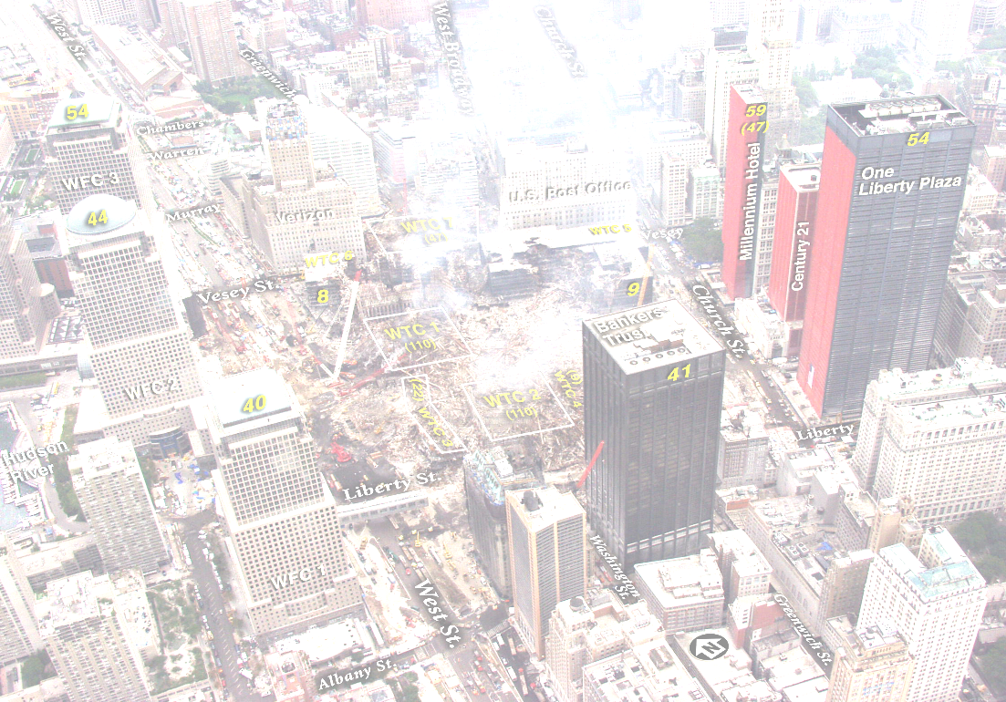
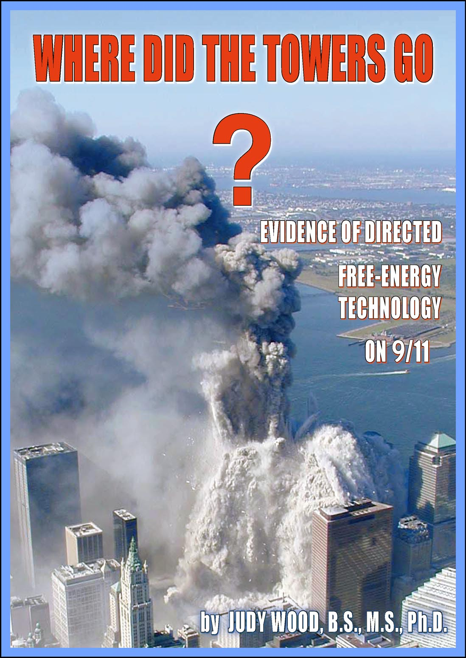

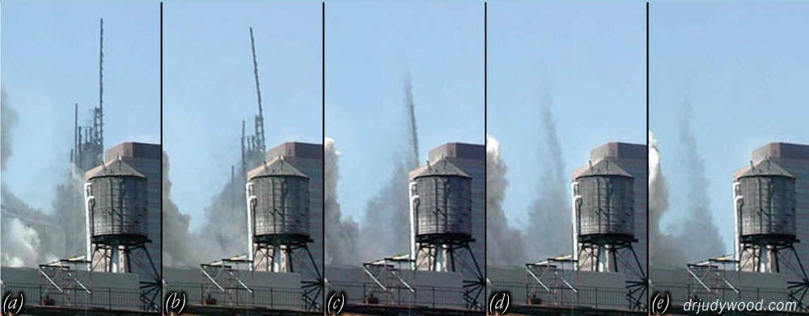
On 11 Sept 2001, astounding events unfolded in the USA – including the complete destruction of World Trade Centre Towers 1, 2 and 7. These events changed the world – changed all our lives. Yet, it was years later that an official investigation was launched. All mainstream media sources generally take a view that those official investigations were adequate - and no one should have cause to seriously question them. However, the pictures on the left show that WTC 1 (like WTC 2) did not “burn up”, nor did it “slam down” – it was turned mostly into dust in mid air – leaving very little of the building itself.
Dr Judy Wood, a former Professor at Clemson University, USA, with degrees in Civil Engineering, Applied Physics and Materials Engineering Science, will present rarely seen graphic evidence which proves what really happened to those enormous structures. Her detailed scientific study exposes a challenging conclusion which most people have never had a chance to see, hear and evaluate. Dr Wood is the only person to submit elements of her forensic study in a US Federal court case in 2007, news of which was censored.
If you want to know more,
please bring as many people as you can
to this unique event - and study the evidence.
www.wheredidthetowersgo.com
www.drjudywood.com

Dr Judy Wood

Where Did The Towers Go?

Sunday 15th March 2015 - Doors Open 1:45pm for 2.00 pm Start
Blinn College Student Center
902 College Ave. Brenham, Texas 77833
Open door @ north handicap entrance
Free Admission - Donations Welcome
For further information / updates see: https://www.facebook.com/drjudywood

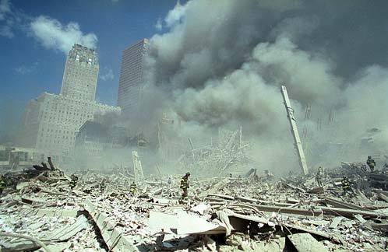
www.wheredidthetowersgo.com - www.drjudywood.com - www.checktheevidence.com - www.richplanet.net www.nomoregames.net
www.wheredidthetowersgo.com - www.drjudywood.com - www.checktheevidence.com - www.richplanet.net www.nomoregames.net
By about 1pm on 9/11, where had the towers gone? Where is the debris? (This photo was taken at ground level.)
Here’s a small selection of the 911 Evidence that needs to be explained…
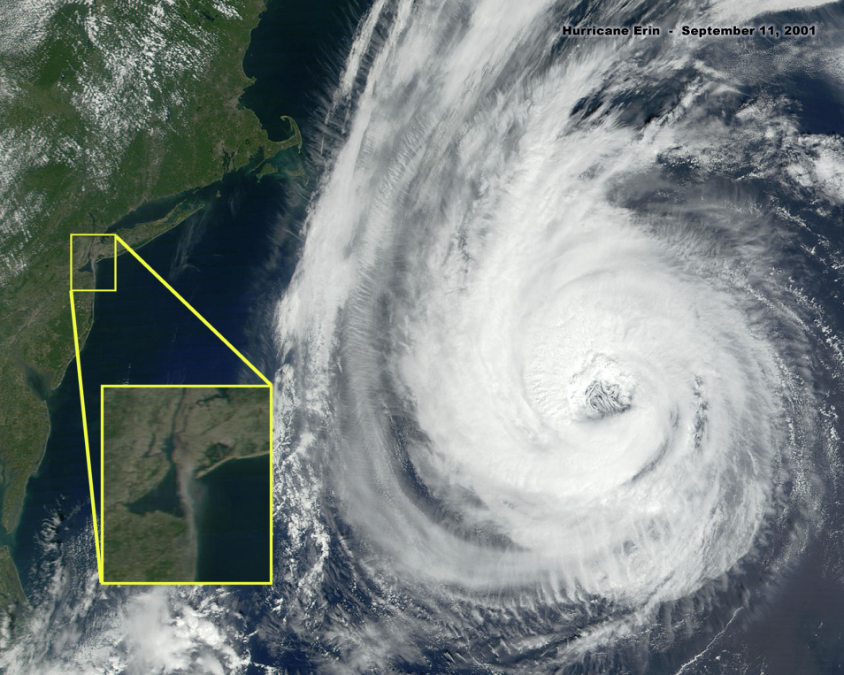
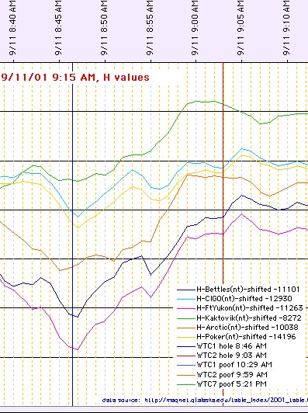
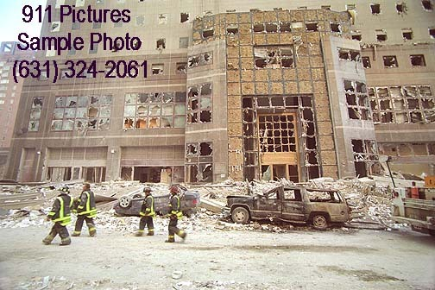
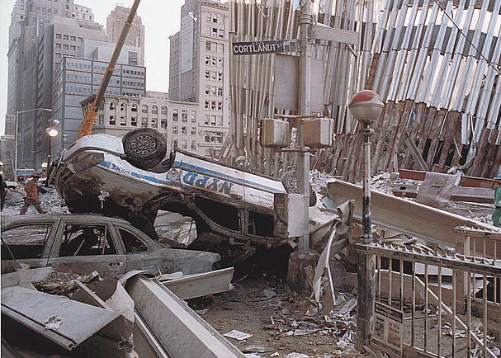
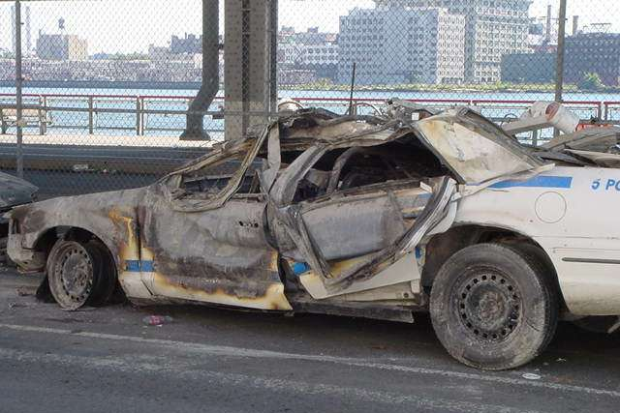
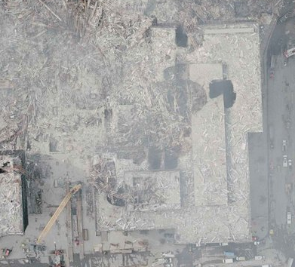
www.wheredidthetowersgo.com - www.drjudywood.com - www.checktheevidence.com - www.richplanet.net - www.nomoregames.net
What caused the door to wilt – without damaging the rear tire?
Why were some cars UPSIDE DOWN?
Why was Hurricane Erin closest to NYC at 8am on 9/11? Why was it barely reported?
Do plane crashes affect the earth’s magnetic field – 3500 miles away?

PTO for details of a meeting which will discuss this evidence – and more!
What caused circular cut-outs in the buildings and the street?

