WHAT REALLY HAPPENED ON 9/11/01?
- 3000 people were killed in the USA.
- Many more people have since been killed in the wars in Iraq, Afghanistan etc.
- We are constantly told of the threat of terrorism.
Thousands of people in Britain, Ireland and around the world have looked at the evidence and are now asking their Governments and the Media:
WHERE DID THE WTC TOWERS GO?
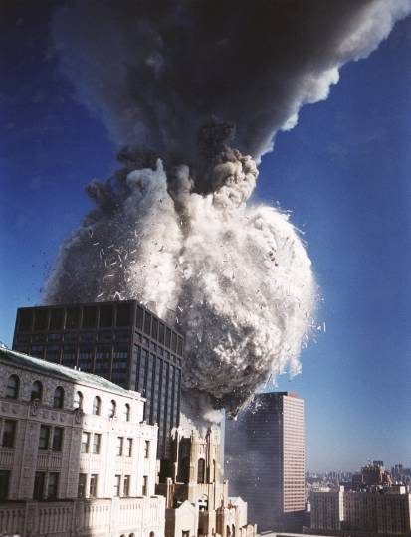 | THE BUILDINGS TURNED TO DUST!  The buildings did not “collapse”, “burn down”, nor did they “explode”.  WHERE DID  THE BUILDING GO? | 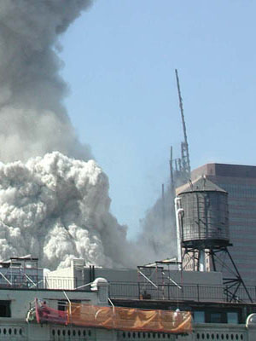  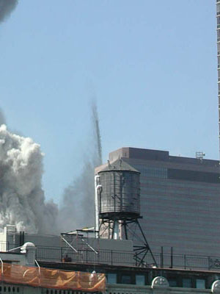
Hint: What is dustifying steel & concrete, 100 storeys up in the air? Gravity? How is gravity and jet fuel completely destroying the building, leaving only paper, dust and a debris pile less than 3 storeys high?  On the afternoon of 9/11/01 the "rubble pile" left from WTC1 is essentially non-existent. WTC7 can be seen in the distance, revealing the photo was taken before 5:20 PM that day. |  |  | 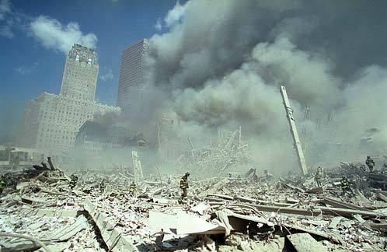
DOES THIS MAKE ANY DIFFERENCE TO YOU?
PLEASE READ ON if you want to know the answer (and no, it isn’t religious.)
There are HUNDREDS of substantiated facts about the destruction of the World Trade Centre and other events on 9/11/2001 that make the official government and mainstream media explanation of these events implausible and/or impossible. A few of these facts – and some pertinent questions - are listed below…
PHYSICAL EVIDENCE
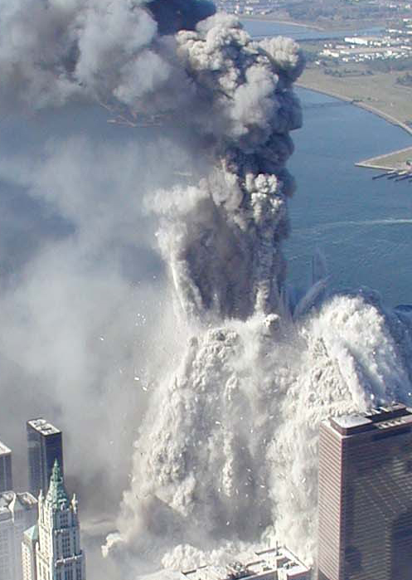
- The government’s "gravity alone” theory of the collapses of the World Trade Centre buildings DEFY the simple laws of physics. In order to “collapse” at the documented rate/speed of collapse (near free fall speed, 10 seconds for towers #1 and #2, 6.6 seconds for building #7), it was IMPOSSIBLE without some other mechanism being used to remove supporting internal building structure (steel and concrete) that would slow down the descent to a considerable degree. Also, WTC 1 & 2 turned to dust in about 10 seconds each! Google “911 BBE”.
Does this look like a “collapse”?
- The physics (speed and volume) of the dust clouds and debris as well as the fineness of the dust point conclusively to something other than a gravity-fed building collapse, started by low-temperature kerosene fires. Google
- No other steel buildings in history before or after have been powderised due to fire or airplane impact or a combination of the two, despite longer and considerably more intense fires elsewhere. Fire does not cause buildings to turn to dust. Google “wtc turns to dust”.
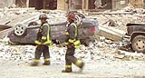
- The Bathtub – in which the WTC was constructed – was undamaged following the disappearance of the buildings. This indicates no significant weight of material hit the ground in solid form. Again, this is also indicated by the Seismic Signature. Google “wtc seismic bathtub”.
- There is abundant eyewitness testimony by news people, firemen, policemen, and bystanders of unusual events, such exploding cars, strange fires and instances of people being lifted off the ground. What happened? Why are there so many inconsistencies in the photographic and video record? Google “911 levitation”
- Google for photos of Edna Cintron - how can ¼ inch aluminium wing struts have cut through 3-inch steel girders? (See Newton’s 3rd law). Google “911 NYC search Planes”.
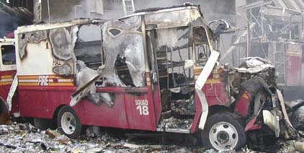
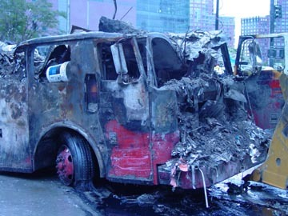
- Only buildings with a WTC complex were destroyed (all 7). Some damage was caused to the Deutsche Bank/Banker’s Trust building across the road from the WTC – it was repaired, then taken down piece by piece - why? Google “wtc prefix destroyed”
- Why did BBC World report the Collapse of WTC 7 twenty minutes before it actually occurred?
- The aftermath of the destruction of the WTC was very strange – virtually no debris left, cars toasted almost 1 mile away, cars turned upside down – what really happened? (Right: Where is the engine block of the fire truck?)
- Why did lots of paper not burn in the supposed fires on 9/11?
HURRICANE ERIN IN THE ATLANTIC - ON 9/11
Was it just a coincidence that a Hurricane was at its closest to NYC on 9/11? Why was it barely reported, when it was bigger than Hurricane Katrina? Data from Alaska shows how the earth’s magnetic field mysteriously changed throughout the events of 9/11. Do plane crashes affect the earth’s magnetic field – 3500 miles away? See http://www.drjudywood.com/ | 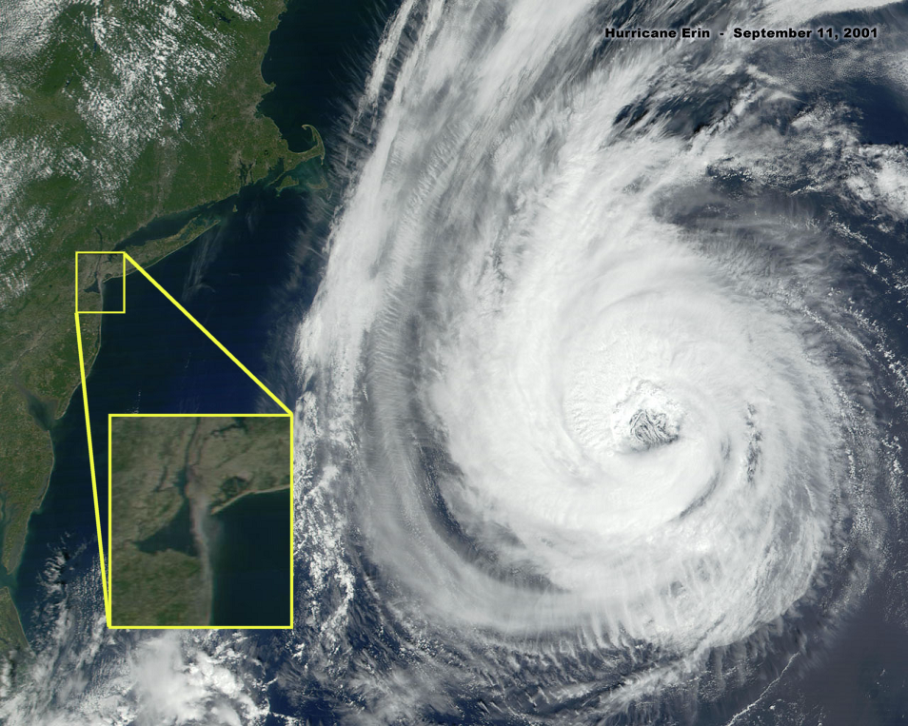 |  | 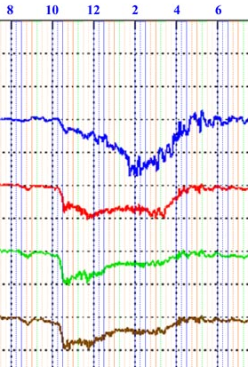
WHO HAS SPOKEN OUT OR TAKEN ACTION TO QUESTION 9/11 ?
Michael Meacher MP, Richard Clarke, Republican Congressman Curt Weldon, Sibel Edmonds (FBI interpreter), David Shayler (former MI5 officer), Dr Morgan Reynolds (economist in GW Bush administration – in April 2007 he sued NIST’s contractors for fraud), Dr Judy Wood (Professor of Mechanical Engineering - in April 2007 she sued NIST’s contractors for fraud), Jesse Ventura (former Governor of Minnesota), Professor Eric Larsen (City University of New York), Jerry Leaphart (Attorney), Mary Sean Young (“Bladerunner”), Jim Corr (of the group The Corrs) and many, many more. PLEASE LOOK ONLINE TO SEE BETTER PICTURES THAN ARE POSSIBLE TO SHOW IN SHORT A5 LEAFLET |  | 
“EXCUSE ME, BUT WHY HAVEN’T I HEARD ABOUT ANY OF THIS?”
It’s hard to believe, but the BBC and mainstream media have all but covered up all of this information (with the exception, a 2 or 3 documentaries and newspaper articles which don’t include a full discussion of evidence presented here). This is why I have made this leaflet myself. Various people have repeatedly advised the BBC and all other mainstream media of the points mentioned above. They have completely ignored the available evidence and have written articles mocking those who ask that the evidence be studied. No prominent public figures in the UK will speak candidly about this evidence. Perhaps it is too challenging to realise the truth…? Are you up to the challenge?
911 – COURT CASE – FILED AS LONG AGO AS 2007
In 2007, Dr Judy Wood and Dr Morgan Reynolds filed court cases based on a forensic study of the evidence pertaining to the destruction of the WTC. The defendants were people who had helped produce the 2005 NIST technical reports about the WTC’s destruction. The evidence was never really put before a court. The media and the “truth movement” covered up knowledge of the court case. All this is documented in “911 Finding the Truth” – available as a free e-book and audio book online. Perhaps those high up wanted to hide the knowledge that….
WEAPONISED DIRECTED “FREE ENERGY” TECHNOLOGY DESTROYED THE WTC ON 9/11
The evidence shows that the “WAR ON TERROR” IS FAKE, set up to scare you, so that you will be persuaded to give up elements of your freedom in exchange for a perceived increase in security. For example, in Oct 2007, Gordon Brown proposed a National Security Agency in the UK.
For more information, or to obtain free Documentary DVD’s (donations requested), please contact ad.johnson@ntlworld.com or simply visit the Websites listed below.
www.wheredidthetowersgo.com - www.drjudywood.com - www.checktheevidence.com – www.richplanet.net - www.nomoregames.net
Please CHECK and SHARE THIS INFORMATION – though shocking and unbelievable, it is of the UTMOST IMPORTANCE. THANK YOU for reading this.
Google “9/11 and the Hutchison Effect”

