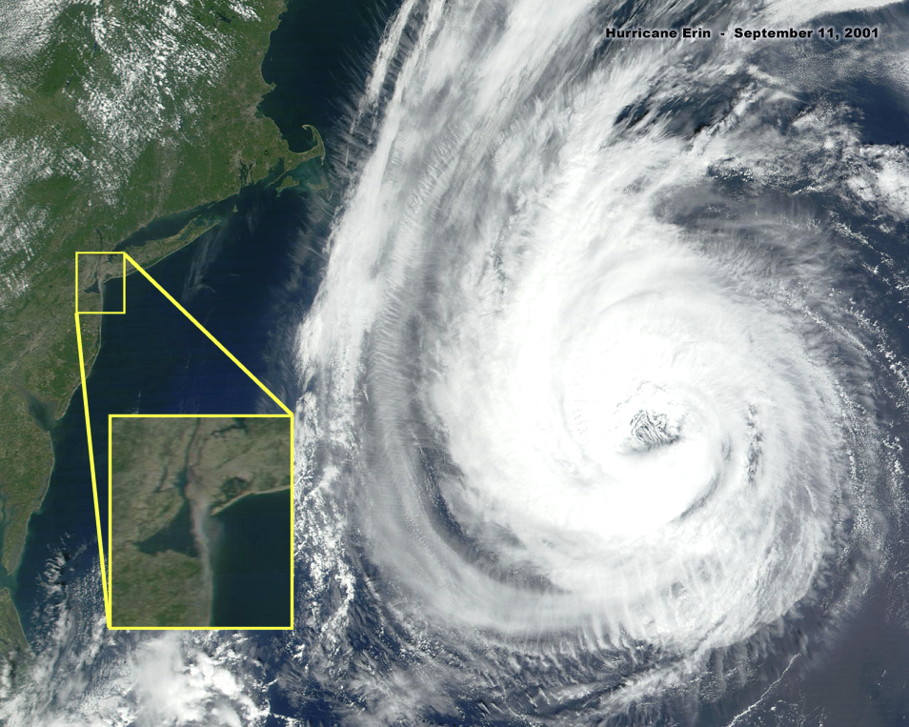  PLEASE STICK THESE ON PHONE BOXES, BUS STOPS, ATM’s, PUBLIC TOILETS etc  www.drjudywood.com | www.checktheevidence.com
www.drjudywood.com
www.checktheevidence.com
www.drjudywood.com
www.checktheevidence.com
www.drjudywood.com
www.checktheevidence.com

